LIGHTSTONE ACUPUNCTURE

CONFIDENTIAL HEALTH HISTORY

Welcome! Please take the time to fill out this questionnaire fully. Your answers are strictly confidential. If you have any questions, please feel free to ask.

Date:

Name: Sex: ☐ M ☐ F
Age: Date of Birth:
Home Address:

Home Phone: Cell: Work Phone:
Email:

Emergency Contact: Relationship to Patient:
Emergency Contact Phone number:

Primary Care Physician (PCP): PCP Phone:
Date of last medical examination:
Occupation:
Who referred you?

Are you currently pregnant?________________Are you presently trying to get pregnant?_______________________

Have you received acupuncture treatment before? YES NO

If yes, for what conditions and what was the outcome?

What would like treated by acupuncture?

Primary Complaint:

Secondary Complaint:
  - PRIMARY COMPLAINT:
    - Briefly explain history of your Primary Complaint, i.e. how long have you had this condition; was the onset SUDDEN or GRADUAL; was there a significant event that lead to this condition?

    - Have you seen a physician (or other primary care provider) for your Primary Complaint? If yes, when and what diagnosis did you receive?

    - Other Care: what other therapies are you doing/ have you done to manage your Primary Complaint, e.g. physical therapy, medication, chiropractic, etc.? Did these/ are these other therapies helping?

  - SECONDARY COMPLAINT:
    - Briefly explain history of your Secondary Complaint, i.e. how long have you had this condition; was the onset SUDDEN or GRADUAL; was there a significant event that lead to this condition?

    - Have you seen a physician (or other primary care provider) for your Secondary Complaint? If yes, when and what diagnosis did you receive?

    - Other Care: what other therapies are you doing/ have you done to manage your Secondary Complaint, e.g. physical therapy, medication, chiropractic, etc.? Did these/ are these other therapies helping?

  - On the diagram, please shade in the areas where you feel symptoms associated with your complaints. PLEASE NUMBER THE COMPLAINTS (Primary Complaint = #1; Secondary Complaint = #2):

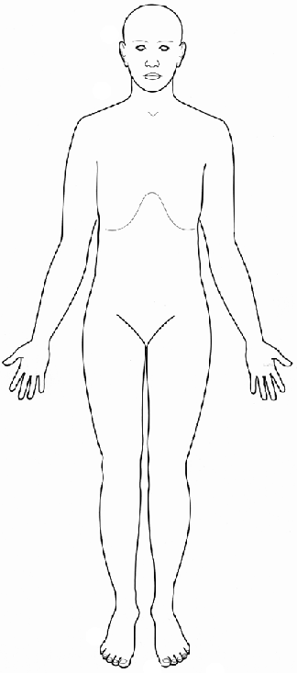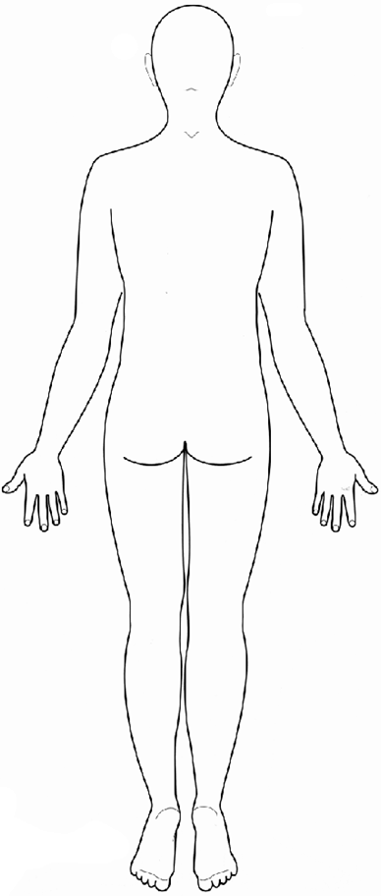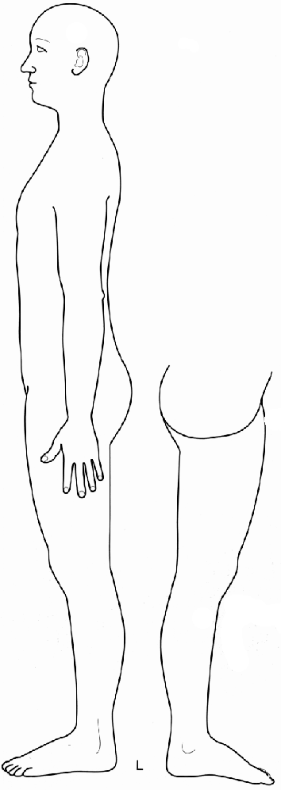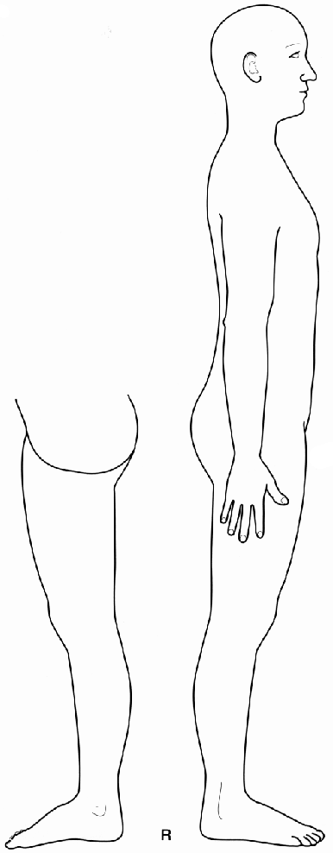
Medical History

Please describe any significant accidents, injuries, trauma, illnesses, and surgeries:

Birth complications/trauma (your own), if any_________________________________________________
Age ______________________________________________________________________________________
Age ______________________________________________________________________________________
Age ______________________________________________________________________________________
Age ______________________________________________________________________________________
Age ______________________________________________________________________________________
Age ______________________________________________________________________________________
Age ______________________________________________________________________________________
Age ______________________________________________________________________________________

Vaccination History: Any unusual reaction? Any unusual vaccination?

Medications, Supplements and herbs
Please list all medications, (prescriptions and over-the-counter drugs) supplements and/or herbs you are CURRENTLY taking:

Medications, supplements, or herbs: Indication/For treatment of:
1. 1.
2. 2.
3. 3.
4. 4.
5. 5.
6. 6.
7. 7.
8. 8.
9. 9.
10. 10.

LIST ANY ALLERGIES (to medications, supplements, herbs):

Family Medical History
Please note all major illnesses in your close family, e.g. diabetes, heart disease, hypertension, neurological disorders, psychological disorders, blood disorders, cancer, high cholesterol, etc.

Mother
Father
Siblings
Maternal Grandparents
Paternal Grandparents
  - Symptom Overview BY System
Please check all symptoms that you are CURRENTLY experiencing AND/OR experience FREQUENTLY. Please indicate (by circling) if the symptom is acute, chronic or experienced frequently.
- A = Acute (under 3 months)
- C = Chronic (over 3 months—experience at some point most days)
- F = Experience frequently (on & off)

Musculoskeletal
A C F Joint clicking
A C F Limitation of movement
A C F Stiffness
A C F Spasms or cramps
A C F Swelling
A C F Weakness
A C F Pain: Full body
A C F Pain: Facial (e.g. jaw)
A C F Pain: Neck
A C F Pain: Upper Back
A C F Pain: Mid Back
A C F Pain: Low Back
A C F Pain: Shoulder
A C F Pain: Elbow
A C F Pain: Wrist
A C F Pain: Hand
A C F Pain: Hip
A C F Pain: Knee
A C F Pain: Ankle
A C F Pain: Foot
A C F OTHER (Please list)

Eyes, Ears, Nose & Throat
A C F Loss of vision
A C F Eye pain
A C F Tearing or eye dryness
A C F Eye discharge
A C F Eye redness
A C F Ear discharge
A C F Ear itching
A C F Ear pain &/or infections
A C F Loss of hearing
A C F Ringing or buzzing in ears
A C F Problems with balance (vertigo)
A C F Olfaction (sense of smell) impaired
A C F Nose obstruction (stuffiness)
A C F Nose bleeds
A C F Sinus pain, pressure &/or infections
A C F OTHER (Please list)

Respiratory
A C F Chest pain &/or tightness
A C F Bluish discoloration of skin
A C F Cough
A C F Coughing up blood (hemoptysis)
A C F Shortness of breath (dypsnea)
A C F Sore throat
A C F Sputum production
A C F Voice changes
A C F Wheezing
A C F OTHER (Please list)

Cardiovascular
A C F Changes in skin temperature & color
A C F Chest pain &/or pressure
A C F Edema
A C F Fainting (syncope)
A C F Fatigue
A C F Palpitations
A C F Skin ulceration
A C F Swelling of the ankles &/or legs
A C F OTHER (Please list)

Digestive
A C F Abdominal distention/bloating
A C F Abdominal mass
A C F Abdominal pain
A C F Acid regurgitation &/or Heartburn
A C F Alternating constipation/diarrhea
A C F Rectal bleeding
A C F Constipation
A C F Diarrhea
A C F Gas
A C F Eating disorder
A C F Indigestion
A C F Jaundice (yellow tint to skin &/or eyes)
A C F Nausea
A C F Vomiting
A C F OTHER (Please list))

Urogenital
A C F Difficulty with urine flow
A C F Incontinence
A C F Painful urination (dysurea)
A C F Rashes
A C F Red urine
A C F Urinary tract infection (UTI)
A C F OTHER (Please list)

Neurological
A C F Changes in consciousness
A C F Confusion
A C F Difficulty concentrating
A C F Dizziness
A C F Dysphasia (impaired ability to speak)
A C F Gait disturbance
A C F Headache
A C F Numbness and/or tingling
A C F Loss of consciousness
A C F Paralysis
A C F Post shingles pain
A C F Problems coordinating movements
A C F Severe forgetfulness
A C F Tremor
A C F Visual disturbance
A C F Weakness
A C F OTHER (Please list)

Integumentary (Skin)
A C F Changes in hair
A C F Changes in nails
A C F Changes in skin color
A C F Itching (prurites)
A C F Never sweat
A C F Rash and/or skin lesion
A C F Unusual sweating
A C F Wounds that will NOT heal
A C F OTHER (Please list)

Psychological
A C F Feelings of grief
A C F Feeling of sadness
A C F Feeling fearful/anxious/nervous
A C F Difficulty managing anger
A C F Feeling manic
A C F Feeling worried or overly pensive
A C F Feelings of panic
A C F Feeling overwhelmed
A C F Extreme mood swings
A C F Extreme lack of emotion
A C F OTHER (Please list)

Sleep
A C F Difficulty falling asleep
A C F Dream disturbed sleep
A C F Wake up & cannot fall back asleep
A C F OTHER (Please list)

Miscellaneous
A C F Extremely low energy/fatigue
A C F OTHER (Please list)

FOR WOMEN ONLY

A C F Abnormal vaginal bleeding
A C F Changes in hair distribution
A C F Fertility concerns
A C F Irregular menstruation
A C F Menopausal symptoms
A C F No menses
A C F Pain with menses (dysmenorrhea)
A C F Pain during or after sexual relations
A C F Pelvic pain
A C F Premenstrual symptoms
A C F Sexual dysfunction
A C F Unusual discharge
A C F OTHER (Please list)

Have you ever been pregnant? YES NO If yes, how many pregnancies:

# Births
# Miscarriages
# Abortions

FOR MEN ONLY

A C F Fertility concerns
A C F Prostate problems
A C F Sexual dysfunction
A C F Unusual discharge
A C F OTHER (Please list)

VII. MEDICAL DISEASES/CONDITIONS. Please check all that apply AND indicate (by circling) if it is chronic or if you had the problem in the past, but is now resolved.
- C = Current condition
- P = Past condition, but is now resolved.

C P AIDS/HIV
C P Alcoholism &/or substance addiction
C P Allergies (If yes, pls indicate diagnosis & history)

C P Anemia
C P Asthma
C P Bell’s Palsy
C P Blood clotting disorder (If yes, pls indicate diagnosis & history)

C P Bipolar disorder
C P Cancer (If yes, pls indicate diagnosis & history)

C P Chron’s Disease &/or colitis
C P Chronic Fatigue Syndrome (CFIDS)
C P Depression (Major)
C P Diabetes
C P Eczema
C P Endometriosis
C P Fibroids
C P Infertility
C P Lung disease, e.g. COPD (If yes, pls indicate
diagnosis & history)

C P Fibromyalgia
C P Gallstones
C P Heart disease (If yes, pls indicate diagnosis &
history)

C P Hepatitis A / B / C
C P Hernia
C P Herpes
C P Hypertension
C P Hypoglycemia
C P Irritable Bowel Syndrome (IBS)
C P Joint Replacement (If yes, pls indicate
diagnosis & history)

C P Kidney Stones and/or Disease (If yes, pls
indicate diagnosis & history)

C P Lupus
C P Lyme Disease
C P Lymph node removal
C P Mitral valve prolapse
C P Mood Disorder
C P Mononucleosus
C P Multiple Sclerosis
C P Organ removal or transplant (If yes, pls
indicate diagnosis & history)

C P Osteoarthritis
C P Osteoporosis
C P Pacemaker (heart or stomach)
C P Parkinson’s Disease
C P Pelvic Inflammatory Disease
C P Polio
C P Psoriasis
C P PTSD (Post-Traumatic Stress Disorder)
C P Reflux esophagistis (GERD)
C P Rheumatic fever
C P Rheumatoid arthritis
C P Scarlet Fever
C P Schizophrenia
C P Scoliosis
C P Seizures and /or epilepsy
C P Shingles
C P Sleep Disorder
C P Stroke
C P Schizophrenia
C P Thyroid disease (If yes, pls indicate diagnosis
& history)

C P Ulcer
C P Trigeminal Neuralgia
C P Tuberculosis
C P Vascular disease (e.g. phlebitis) (If yes, pls
indicate diagnosis & history)

C P OTHER (pls list)

  - Lifestyle Information

- Stress, Energy Level & Sleep

- Do you think that stress, including recent major life changes, is contributing to your main complaints and/or negatively impacting any other aspect of your physical or mental health? If yes, briefly describe:

- Do you have any problems with your energy level? If yes, please briefly describe:

- Do you have any problems with sleep? If yes, please briefly describe:

- Do you have any problems with your sexual drive? If yes, please briefly describe:

- Smoking, Alcohol & Drugs

      - Do you smoke tobacco? YES NO If yes, do you believe that this is a problem for you?

      - Do you drink alcohol? YES NO If yes, do you believe that this is a problem for you?

      - Do you use recreational drugs and/or prescription medications that your physician does not know about? YES NO Do you believe that this is a problem for you?

- Diet and Nutrition

      - If applicable, briefly describe any problems you think you have with your eating habits and appetite. Do you believe that your diet has any impact on your complaints? YES NO

      - Are you concerned about your weight and/or appetite (under or overweight, too much or too little appetite)? YES NO

